 PUPPY.COM.MY
THE BEST PLACE FOR YOUR BEST FRIENDS

PUPPY.COM.MY PREMIUM MEMBERSHIP CARD
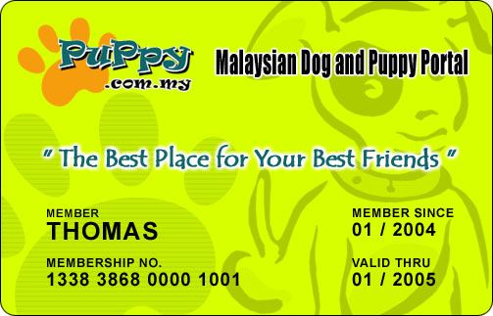
Introducing the PUPPY.COM.MY Premium Membership Card. The Benefits for Puppy.com.my Premium Membership are :-

- Enjoy Priority Registration at all Puppycom Events
- Free Dog Tag with registration
- Discount on Dog Obedience and Agility Training.
- Discount at Online Store at http://shop.puppy.com.my
- Purchase special priced item at Premium Members' Mall at http://pm.puppy.com.my
- Enjoy discount at participating at Dog Grooming Centre.
- Free 30MB of server space at Photo Gallery at Pets2u.com.my.
- Enjoy discount on all Resort Stays organized by Puppy.com.my in the future,
- Enjoy 30% discount on the subscription of all Advertisement for sale of puppies or dogs at Puppy.com.my
- Regular notifications via Email or Snail Mail.

The annual membership fee for the PUPPY.COM.MY's Premium Membership is only RM 50.00.

To apply, just fill up the application form attached and mail it to Puppy.com.my with your payment using the following information :-

Payment to be made in favour of Hileytech Sdn Bhd

Address :-
Puppy.com.my
c/o Hileytech Sdn Bhd
10-1 Jalan Perubatan 2, Pandan Indah
55100 Kuala Lumpur, Malaysia.
Tel : 603.42978281 Fax : 603.42978254 Web : http://www.puppy.com.my/pm

We also accept payment via Credit Card. Payment can be made by Credit Card, VISA Card or MasterCard online at http://www.puppy.com.my/pay.html

Payment can also be made by making deposit into our account number as below :-

 |  | Bank | Account Number
 |  | MBB | 514383-511398
 |  | Public Bank | 3087867020
One funds is deposited into our account, fax the slip to us at +603.42978254

PUPPY.COM.MY
THE BEST PLACE FOR YOUR BEST FRIENDS

APPLICATION FORM FOR PUPPY.COM.MY PREMIUM MEMBERSHIP
[ ANNUAL PREMIUM MEMBERSHIP FEE IS RM 50.00 ONLY ]
Personal Information

Name : __________________________________ Gender : Male / Female

Address : ____________________________________________________________

____________________________________________________________________

____________________________________________________________________

Email : ______________________________________________________________

Contact No.# : (Home)__________(Office)____________(Cell Phone)____________

Dog Information

Breed(s) : _____________________________________ Age : ________________

Name(s) : ___________________________________________________________

Number of dog(s) : ____________________ Sex : __________________________

What brand of dog food you’re using : _____________________________________

General Information

puppy.com.my member : Yes / No Puppy.com.my User Name (if any) : _________

Date :

Signature : ___________________

NOTE : MEMBERSHIP CARD WILL BE POSTED TO YOU WITHIN 2 WEEKS OF YOUR APPLICATION.

Declaration : I apply to become a member of the Puppy.com.my and I agree to abide by all Rules and Regulations, Terms and Conditions of Puppy.com.my (Hileytech Sdn Bhd) that which are inforced and may be inforced during the period of my membership.

